***Project Report***

***On***

***Cab fare Prediction***

AUTHOR: Sarbasis Abhishek Nanda



INDEX



* 1. Problem Statement
  2. Data



* + - Pre-Processing
    - Modelling
    - Model Selection



* 1. Data exploration and Cleaning (Missing Values and Outliers)
  2. Creating some new variables from the given variables
  3. Selection of variables
  4. Some more data exploration
     + Dependent and Independent Variables
     + Uniqueness of Variables
     + Dividing the variables categories
  5. Feature Scaling



* 1. Linear Regression
  2. Decision Tree
  3. Random Forest
  4. Hyper Parameters Tunings for optimizing the results



* 1. Model Evaluation
  2. Model Selection
  3. Some Visualization facts



**Chapter 1**

**Introduction**

Now a day’s cab rental services are expanding with the multiplier rate. The ease of using the services and flexibility gives their customer a great experience with competitive prices.

* 1. **Problem Statement**

You are a cab rental start-up company. You have successfully run the pilot project and now want to launch your cab service across the country. You have collected the historical data from your pilot project and now have a requirement to apply analytics for fare prediction. You need to design a system that predicts the fare amount for a cab ride in the city.

* 1. **Data**

Understanding of data is the very first and important step in the process of finding solution of any business problem. Here in our case our company has provided a data set with following features, we need to go through each and every variable of it to understand and for better functioning.

Size of Dataset Provided: - 16067 rows, 7 Columns (including dependent variable) Missing Values: Yes

Outliers Presented: Yes

Below mentioned is a list of all the variable names with their meanings:

|  |  |
| --- | --- |
| **Variables** | **Description** |
| **fare_amount** | Fare amount |
| **pickup_datetime** | Cab pickup date with time |
| **pickup_longitude** | Pickup location longitude |
| **pickup_latitude** | Pickup location latitude |
| **dropoff_longitude** | Drop location longitude |
| **dropoff_latitude** | Drop location latitude |
| **passenger_count** | Number of passengers sitting in the cab |

**Chapter 2**

**Methodology**

* + - **Pre-Processing**

When we required to build a predictive model, we require to look and manipulate the data before we start modelling which includes multiple preprocessing steps such as exploring the data, cleaning the data as well as visualizing the data through graph and plots, all these steps is combined under one shed which is **Exploratory Data Analysis**, which includes following steps:

* + - * Data exploration and Cleaning
      * Missing values treatment
      * Outlier Analysis
      * Feature Selection
      * Features Scaling
      * Skewness and Log transformation
      * Visualization
    - **Modeling**

Once all the Pre-Processing steps has been done on our data set, we will now further move to our next step which is modeling. Modeling plays an important role to find out the good inferences from the data. Choice of models depends upon the problem statement and data set. As per our problem statement and dataset, we will try some models on our preprocessed data and post comparing the output results we will select the best suitable model for our problem. As per our data set following models need to be tested:

* + - * Linear regression
      * Decision Tree
      * Random forest,
* We have also used hyper parameter tunings to check the parameters on which our model runs best.
  + Grid Search CV
    - **Model Selection**

The final step of our methodology will be the selection of the model based on the different output and results shown by different models. We have multiple parameters which we will study further in our report to test whether the model is suitable for our problem statement or not.

**Chapter 3**

**Pre-Processing**

# Data exploration and Cleaning (Missing Values and Outliers)

The very first step which comes with any data science project is data exploration and cleaning which includes following points as per this project:

* + 1. Separate the combined variables.
    2. As we know we have some negative values in fare amount so we have to remove those values.
    3. Passenger count would be max 6 if it is a SUV vehicle not more than that. We have to remove the rows having passengers counts more than 6 and less than 1.
    4. There are some outlier figures in the fare (like top 3 values) so we need to remove those.
    5. Latitudes range from -90 to 90. Longitudes range from -180 to 180. We need to remove the rows if any latitude and longitude lies beyond the ranges.

# Creating some new variables from the given variables.

Here in our data set our variable name pickup_datetime contains date and time for pickup. So we tried to extract some important variables from pickup_datetime:

* Year
* Month
* Date
* Day of Week
* Hour
* Minute

Also, we tried to find out the distance using the haversine formula which says:

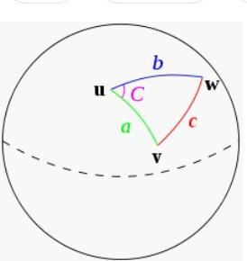The **haversine formula** determines the great-circle distance between two points on a sphere given their longitudes and latitudes. Important in navigation, it is a special case of a more general formula in spherical trigonometry, the law of haversines, that relates the sides and angles of spherical triangles.

So our new extracted variables are:

* + fare_amount
  + pickup_datetime
  + pickup_longitude
  + pickup_latitude
  + dropoff_longitude
  + dropoff_latitude
  + passenger_count
  + year
  + Month
  + Date
  + Day of Week
  + Hour
  + Minute
  + Distance

# Selection of variables

Now as we know that all above variables are of now use so we will drop the redundant variables:

* pickup_datetime
* pickup_longitude
* pickup_latitude
* dropoff_longitude
* dropoff_latitude
* Minute

Now only following variables we will use for further steps:

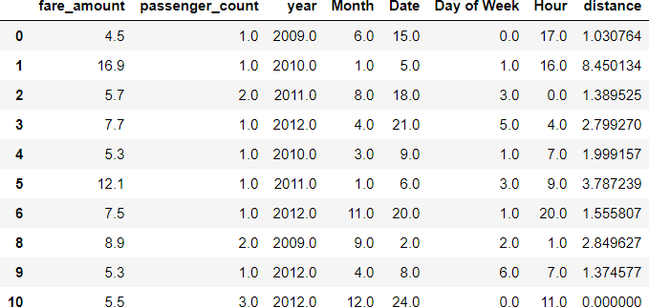

|  |  |
| --- | --- |
| VariableNames Variable DataTypes | |
| fare_amount | float64 |
| passenger_count | object |
| year | object |
| Month | object |
| Date | object |
| Day of Week | object |
| Hour | object |
| distance | float64 |

# Some more data exploration

In this report we are trying to predict the fare prices of a cab rental company. So here we have a data set of 16067 observations with 8 variables including one dependent variable.

* + 1. **Below are the names of Independent variables:**

**passenger_count, year, Month, Date, Day of Week, Hour, distance**

Our Dependent variable is: **fare_amount**

* + 1. **Uniqueness in Variable**

We need to look at the unique number in the variables which help us to decide whether the variable is categorical or numeric. So, by using python script ‘nunique’ we tried to find out the unique values in each variable. We have also added the table below:

|  |  |
| --- | --- |
| **Variable Name** | **Unique Counts** |
| fare_amount | 450 |
| passenger_count | 7 |
| year | 7 |
| Month | 12 |
| Date | 31 |
| Day of Week | 7 |
| Hour | 24 |
| distance | 15424 |

* + 1. **Dividing the variables into two categories basis their data types:**

Continuous variables - 'fare_amount', 'distance'.

Categorical Variables - 'year', 'Month', 'Date', 'Day of Week', 'Hour', 'passenger_count'

# Feature Scaling

**Skewness** is asymmetry in a statistical distribution, in which the curve appears distorted or skewed either to the left or to the right. Skewness can be quantified to define the extent to which a distribution differs from a normal distribution. Here we tried to show the skewness of our variables and we find that our target variable absenteeism in hours having is one sided skewed so by using **log transform** technique we tried to reduce the skewness of the same.

Below mentioned graphs shows the probability distribution plot to check distribution before log transformation:

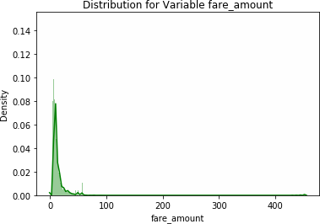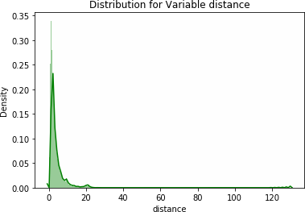

Below mentioned graphs shows the probability distribution plot to check distribution after log transformation:

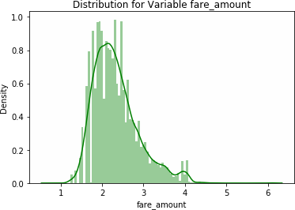

As our continuous variables appears to be normally distributed so we don’t need to use feature scaling techniques like normalization and standardization for the same.

**Chapter 4**

**Modelling**

After a thorough preprocessing, we will use some regression models on our processed data to predict the target variable. Following are the models which we have built –

Linear Regression Decision Tree Random Forest

# Before running any model, we will split our data into two parts which is train and test data. Here in our case we have taken 80% of the data as our train data. Below is the snipped image of the split of train test.

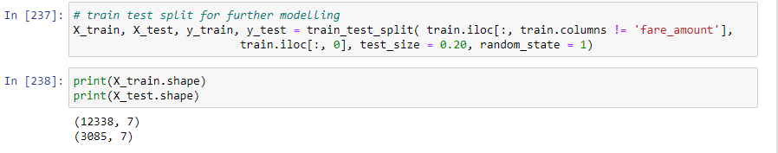

* 1. **Linear Regression**

[Multiple linear regression](http://www.statisticssolutions.com/academic-solutions/membership-resources/member-profile/data-analysis-plan-templates/data-analysis-plan-multiple-linear-regression/) is the most common form of linear regression analysis. Multiple regression is an extension of simple linear regression. It is used as a predictive analysis, when we want to predict the value of a variable based on the value of two or more other variables. The variable we want to predict is called the dependent variable (or sometimes, the outcome, target or criterion variable).

Below is a screenshot of the model we build and its output:

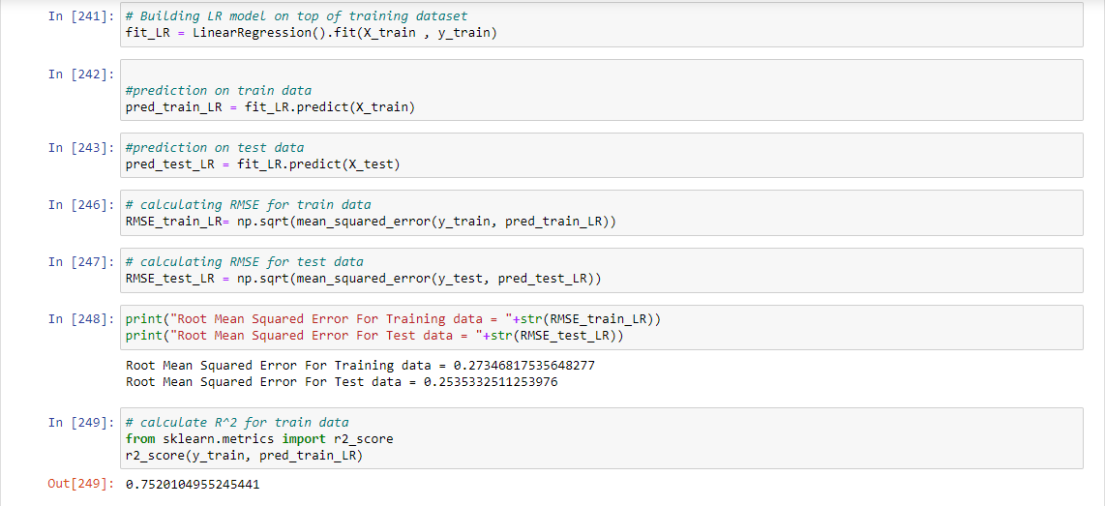

* 1. **Decision Tree**

A tree has many analogies in real life, and turns out that it has influenced a wide area of machine learning, covering both classification and regression. In decision analysis, a decision tree can be used to visually and explicitly represent decisions and decision making. As the name goes, it uses a tree-like model of decisions.

Below is the screenshot of the query we executed and the result shown, we will compare the results of each model in a combined table later on.

Decision Tree Algorithm

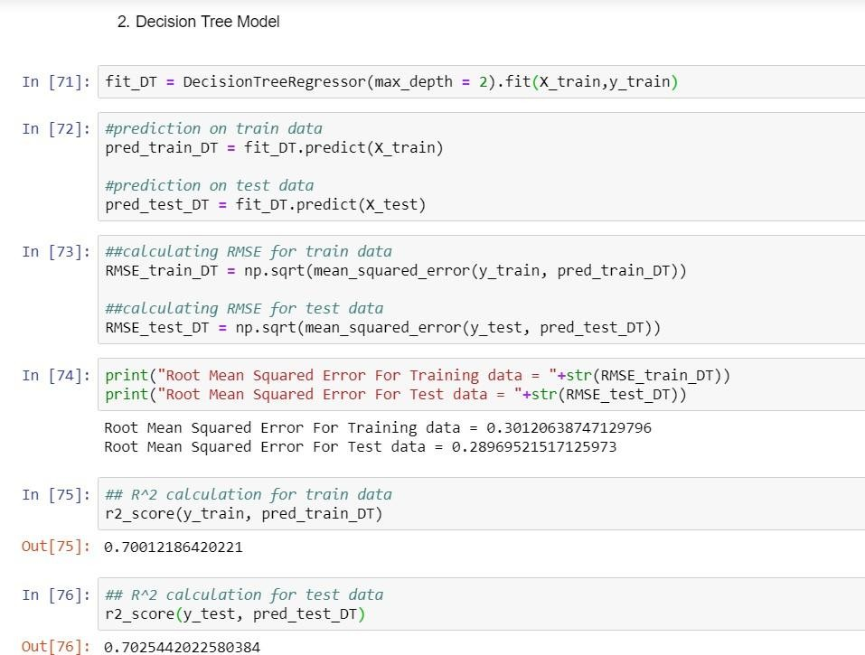

* 1. **Random Forest**

Random forests or random decision forests are an [ensemble learning](https://en.wikipedia.org/wiki/Ensemble_learning) method for classification, regression and other task, that operate by constructing a multitude of [decision trees](https://en.wikipedia.org/wiki/Decision_tree_learning) at training time and outputting the class that is the [mode](https://en.wikipedia.org/wiki/Mode_(statistics)) of the classes (classification) or mean prediction (regression) of the individual trees. Random decision forests correct for decision trees' habit of [overfitting](https://en.wikipedia.org/wiki/Overfitting) to their [training](https://en.wikipedia.org/wiki/Test_set) [set](https://en.wikipedia.org/wiki/Test_set).

# To say it in simple words: Random forest builds multiple decision trees and merges them together to get a more accurate and stable prediction.

Below is a screenshot of the model we build and its output:

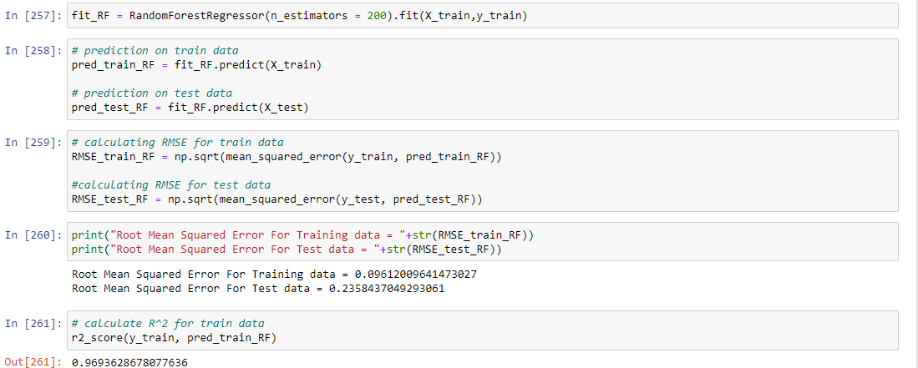



* 1. **Hyper Parameters Tunings for optimizing the results**
     + Here we have used Grid Search CV hyper parameters tuning techniques

1. **Grid Search CV**: This algorithm set up a grid of hyperparameter values and for each combination, train a model and score on the validation data. In this approach, every single combination of hyperparameters values is tried which can be very inefficient.

Check results after using Grid Search CV on Random forest model.

Check results after using Grid Search CV on Random forest model:

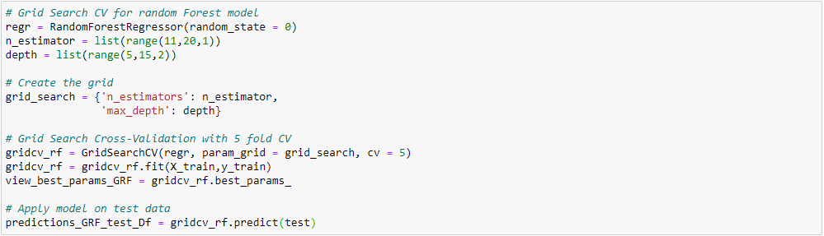

**Chapter 5**

**Conclusion**

* 1. **Model Evaluation**

The main concept of looking at what is called residuals or difference between our predictions f(x[I,]) and actual outcomes y[i].

In general, most data scientists use two methods to evaluate the performance of the model:

* + 1. **RMSE** (Root Mean Square Error): is a frequently used measure of the difference between values predicted by a model and the values actually observed from the environment that is being modelled.



*n*

*i*1

( *X*  *X*

*obs*,*i*

*n*

*mo del*,*i*

)2

*RMSE* 

* + 1. **R Squared(R^2):** is a statistical measure of how close the data are to the fitted regression line. It is also known as the coefficient of determination, or the coefficient of multiple determination for multiple regression. In other words, we can say it explains as to how much of the variance of the target variable is explained.
    2. We have shown both train and test data results, the main reason behind showing both the results is to check whether our data is overfitted or not.

Below table shows the model results before applying hyper tuning:

|  |  |  |  |  |
| --- | --- | --- | --- | --- |
| **Model Name** | **RMSE** | | **R Squared** | |
| **Train** | **Test** | **Train** | **Test** |
| Linear Regression | 0.27 | 0.25 | 0.74 | 0.77 |
| Decision Tree | 0.30 | 0.28 | 0.70 | 0.70 |
| Random Forest model | 0.09 | 0.23 | 0.96 | 0.79 |

* 1. **Model Selection**

On the basis RMSE and R Squared results a good model should have least RMSE and max R Squared value. So, from above tables we can see:

* From the observation of all RMSE Value and R-Squared Value we have concluded that,
* Random Forest perform comparatively well while comparing their RMSE and R-Squared value.
* After this, I chose Random Forest CV and Grid Search CV to apply technique to hyper tunning.

**Finally, I used this method to predict the target variable for the test data file shared in the problem statement. Results that I found are attached with my submissions.**

* 1. **Some more visualization facts:**

1. **Number of passengers and fare**

We can see in below graph that single passengers are the most frequent travelers, and the highest fare also seems to come from cabs which carry just 1 passenger.

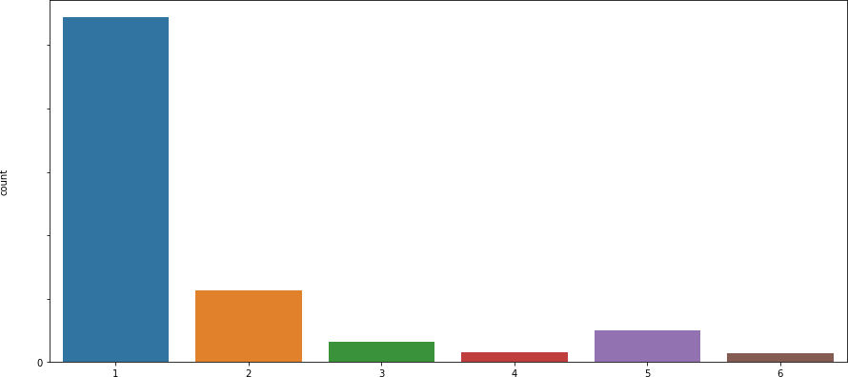

10000

8000

6000

4000

2000



1. **Date of month and fares**

The fares throughout the month mostly seem uniform.

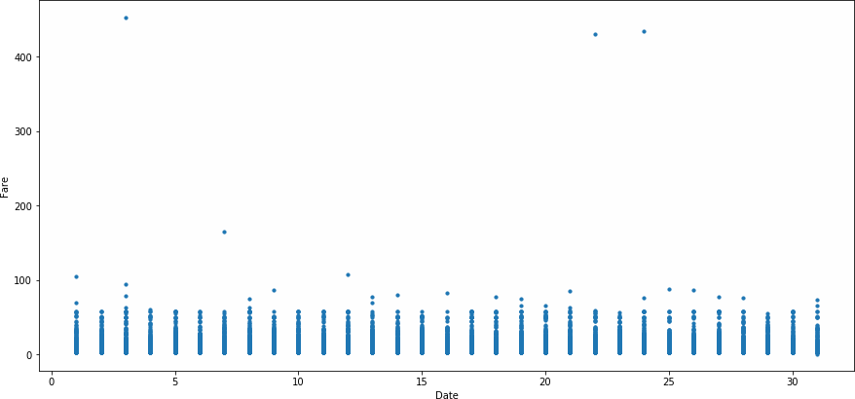

1. **Hours and Fares**
   * During hours 6 PM to 11PM the frequency of cab boarding is very due to peak hours
   * Fare prices during 2PM to 8PM is bit high compared to all other time might be due to high demands.

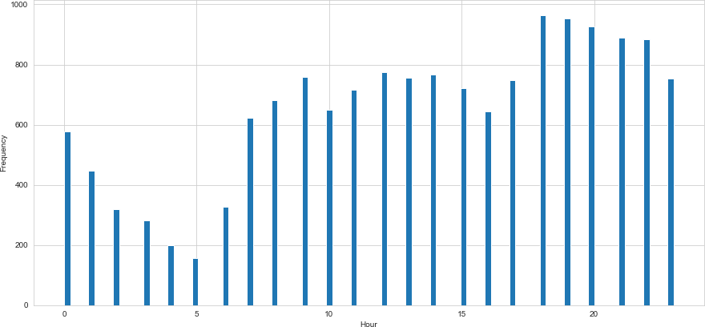

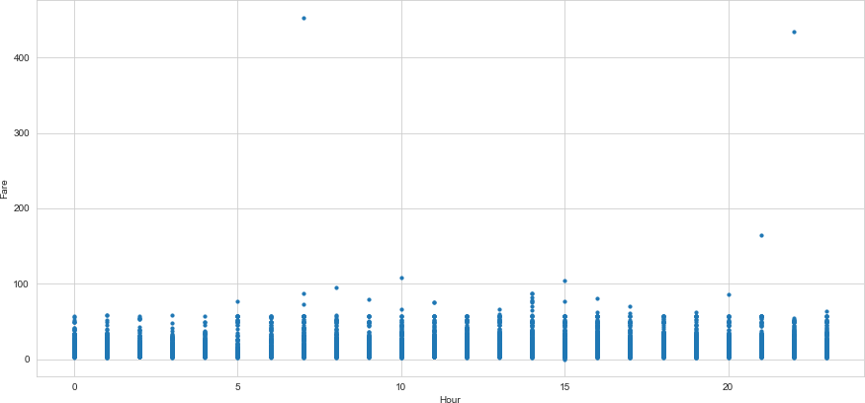

1. **Week Day and fare**
   * Cab fare is high on Friday, Saturday and Monday, may be during weekend and first day of the working day they charge high fares because of high demands of cabs.

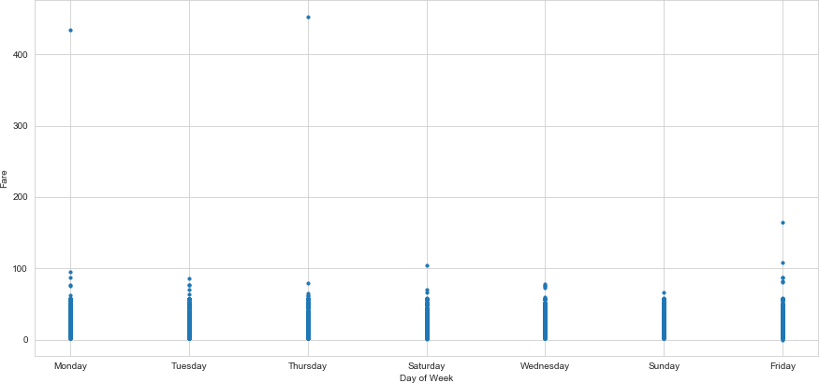

1. **Impact of Day on the Number of Cab rides :**

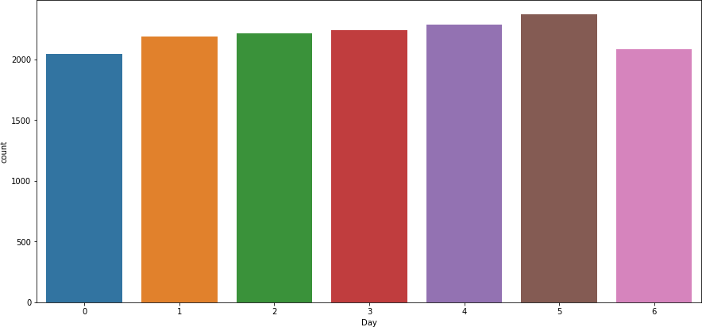

Observation : The day of the week does not seem to have much influence on the number of cabs ride

**References**

1. For Data Cleaning and Model Development - <https://edwisor.com/career-data-scientist>
2. For other code related queries -

[https://www.analyticsvidhya.com/blog/2016/03/practical-guide-principal-component-analysis-](https://www.analyticsvidhya.com/blog/2016/03/practical-guide-principal-component-analysis-python/) [python/](https://www.analyticsvidhya.com/blog/2016/03/practical-guide-principal-component-analysis-python/)

1. For Visualization –

https://towardsdatascience.com/

<https://stackoverflow.com/>